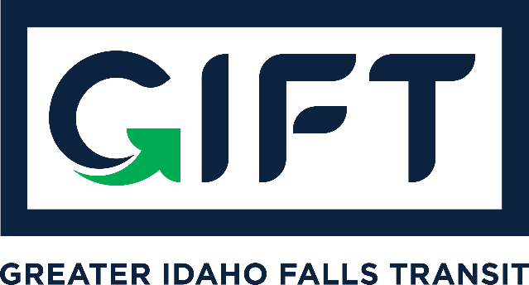

dba TRPTA TARGHEE REGIONAL PUBLIC TRANSPROTATION AUTHORITY | PHONE: 208-612-8323

BOARD MEMBERS PRESENT:
Michelle Ziel-Dingman, Lisa Farris, and Rick Cloutier
ABSENT:
Arnold Cantu
Jan 25, 2023 | 10:00 am – 11:00 pm
Idaho Falls City Annex Building – Small Conference Room
Agenda
- ACTION ITEM: Approve GIFT board meeting December 7, 2022 minutes
    - Motion to approve the minutes made by Cantu and seconded by Walker. Unanimously approved.
- Public Hearing on Fee
- Proposal: Increase GIFT ride fare from $1 to $2 (for federally authorized participants who qualify for a reduced fare) and from $3 to $4 for all other riders.
- No City of Idaho Falls fee change is necessary as the Fee Ordinance has a published fee of $5 and no public hearing or ordinance change is needed if the fees proposed are $5 or less.
- Was properly noticed and advertised three separate times in The Post Register
- Opened Public Hearing at 10:05 a.m. No public comment. Closed the Public Hearing at 10:06 a.m.
- ACTION ITEM: Approve Proposed Fee Increase
    - Board Discussion Begins:
      - Board Member Walker: GIFT is providing a phenomenal value to the community and hopes that other qualifying cities within Bonneville County join the program.
      - Board Member Farris:
    - Motion to support an increase of GIFT ride fare from $1 to $2 (for federally authorized participants who qualify for a reduced fare) and from $3 to $4 for all other riders made by Farris and seconded by Walker. Unanimously approved.
    - Could be implemented as soon as Feb. 1, 2023. Board member Cloutier recommends waiting until March 1, 2023 to allow proper social media, press releases, and other communication to the riders.
- General program update from Kade Marquez:
- Events
      - ITD has given GIFT a vehicle (cutaway bus – ADA accessible and holds lots of luggage) that could use for special events or programs. Kade has approached the Idaho Falls Airport to possibly transform this vehicle primarily into an airport shuttle.
      - When not used for the airport, could be used for special events or on-demand rides near the airport.
      - Board Chair Dingman suggested not to raise the rates for airport rides during normal business hours, only nights and Sundays. However, Kade commented that due to additional luggage needs and availability reserved for the airport, this is worth the additional $1 premium.
      - Not extending hours on Valentine’s Day events due to ITD guidance.
- Ridership & geographics
      - 1,544 federally qualified discounted accounts out of 6,454 total accounts.
      - Federally qualified rides make up about 41% of total rides. This means that 25% of our customers are making 41% of our rides.
      - 50,004 rides since we opened service as of end of day 1/24/23.
      - Continuing to see high ridership and we’re continuing to work on efficiencies.
- Funding and grant applications and opportunities
      - Kade believes that there’s grant opportunities for Ammon and Bonneville County to join our program, but they would need to apply for it. Kade has communicated with the Mayor of Ammon about this. Kade would like to meet with Bonneville County Commissioners on this same issue.
      - Funding from advertising / vehicle wraps represent about $100,000 per year. Partners include College of Eastern Idaho, Mountain View Hospital, and Idaho Falls Community Hospital.
      - ARPA - $327,000 in new money
      - Finished a grant application with the help of Laura Satterlee. Grant is for new electric chargers for vehicles, three bus shelters with electronic signs. Dingman commented that a few years ago, the Idaho Falls City Council approved some changes to ordinances that would allow for new bus shelters with advertising.
      - Call center is costing us about $600 per day ($0.80 per minute) and we need to pursue funding opportunities. One idea is to charge more for those who book rides via phone instead of the app.
      - Could pursue funding to extend hours past 9 p.m. but insurance and risk increases in the nighttime, harder to hire people for these shifts, etc. But funding options are possible.
- Customer service issues
      - 432 people did not show up for rides in 2022. This represents 100 hours of manpower and thousands in lost revenue. We’re now waiting only 2 minutes instead of 5 minutes. The exception is medical facilities. The driver doesn’t leave until they walk into the lobby and try to find the rider.
      - Driver staff members are working together to ensure that customer service is high, especially with riders who need extra help, to ensure that drivers are partnered with some riders who they fit better with.
      - Primary way customers are reporting issues are through the call center followed by the website contact form.
      - Kade is working on a Lost & Found process including a new phone number & new page on the website. After 30 days, lost and found items becomes property of GIFT and GIFT will work with local nonprofits to liquidate.
      - Kade’s office is moving to the Skyline Events Center and customers will be able to see Kade by appointment there and look through lost and found.
- Financial Report from Treasurer
    - ACTION ITEM: Approve Financial Report
      - Walker moved to approve Financial Report, seconded by Cantu. Unanimously approved.
- ACTION ITEM: Approve the release of $20,000 to the City of Idaho Falls for local match requirements.
      - Kade provided input to move this item to the February 2023 agenda to release a certain dollar amount for matching funds after Kade puts all the in-kind donations to use.
      - No vote taken.

Board member Walker made a spontaneous announcement that he needs to resign from the GIFT Board (effective immediately) as he's leaving CEI to spearhead national university partnerships at the INL starting 2/13. Mike believes that CEI representation is crucial to our Board. Mike would like Mayor Casper to consider appointing Hailey Mack, who is the Associate Dean of Students and could possibly be promoted to Mike's position. Mike has spoken to her, and she would love to be in the position.

