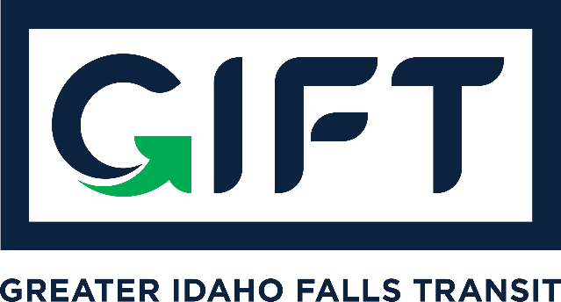

dba TRPTA TARGHEE REGIONAL PUBLIC TRANSPROTATION AUTHORITY PHONE: 208-612-8323

GIFT Board Meeting - Idaho Falls City Annex Building - Sm. Conf. Rm.
June 18, 2024, 10:00 am - 11:00 am

Introductions - Board members present: Lisa Farris, Jim Freeman, Arnold Cantu, Hailey Mack, and Ian Turner. City staff present: Kade Marquez, Margaret Wimborne, and Darrell West.

Welcome McKayla Matlack, ED of DWI.

Discussion Items - Lisa Farris and Kade Marquez.
- Lisa Farris gave a Financial Update (Bank of Commerce account) 5/22/24 thru 6/18/24.
  - Balance of $162,704.03—Everything gets deposited into this account
  - Also a $600,000 CD in a different account (Matures in September)
  - Total funds equal $762,704.03
- Kade explained the relationship with DWI (Development Workshop Incorporated) and the need to better serve those with disabilities, especially financially
  - Explanation of 5310 funds
    - Federal Transportation Administration
    - Generally 20% match
  - How do we create a program for the matching funds and provide transportation solutions for this population
  - McKayla Matlack discussed the history of DWI clients and riding with GIFT. She also discussed DWI Transportation budget and a donation option to be used as match towards 5310 allotments.
  - It was mentioned that Civitans Club might be a good option for matching funds
  - It is anticipated that the amount of match needed at this time would be between $100,000 and $110,000.
- There was discussion regarding the preapproval of spending/negotiating limits for Transit Coordinator. It was determined that $10,000 would be an appropriate amount for now with the understanding that it could be changed at a later date if it is deemed necessary.
  - Jim Freeman made a motion with a second by Lisa Faris to approve s $10,000 spending/negotiating limit for the Transit Coordinator. A vote was taken and all were in favor. Motion passed.
- Kelly Badesheim is coming to the area to provide a training for our board in July. She is not charging for the service, but is asking for her travel expenses to be covered.
  - Jim Freeman made a motion with a second by Arnold Cantu to approve travel expenses for Kelli Badesheim’s travel expenses for up to $1,000. A vote was taken and all were in favor. Motion passed.
- There was a discussion regarding the GIFT by-laws sent to the board in a previous email. There was a suggestion that we think about developing an Executive Board to streamline approvals, etc. It was mentioned that there is a need to revise the bylaws and reorganize how seats on the board are filled or vacated. One suggestion included basing board seats on the ridership. There are several possibilities we need to take to the experts. Term limits is another topic that needs to be considered during the revision.
  - GIFT Policy - define the purpose and difference between by-laws and policy.
  - It was requested that members email comments and suggestions to Lisa who will compile them. Comments should be separated as either policy or by-laws.
- We are asking the City of Idaho Falls to increase their yearly contribution from $160,000 to $410,000. GIFT Board support is encouraged in person or by letter of support. It was suggested that a template for support letters be created.
Action Items - Lisa Farris
- A motion was made by Jim Freeman with a second by Hailey Mack to approve the Financials from 5/19/24 thru 6/18/24. A vote was taken and all were in favor. Motion passed.
- A motion was made by Jim Freeman with a second by Lisa Faris to approve the May 21, 2024, GIFT Board Meeting Minutes with the date correction from May 19 to May 21. A vote was taken and all were in favor. Motion Passed.

Other Next GIFT Board Meeting July 16, 2024
GIFT Board Letter of Support (Template)
Adjourn Meeting adjourned at 11:15 pm.

