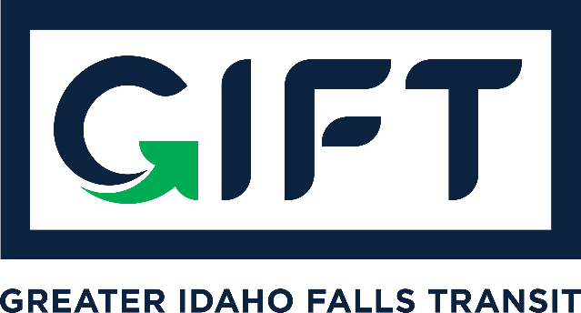

dba TRPTA TARGHEE REGIONAL PUBLIC TRANSPROTATION AUTHORITY | PHONE: 208-612-8323

BOARD MEMBERS:
Michelle Ziel-Dingman, Lisa Farris, Arnold Cantu, and Rick Cloutier.
Feb. 21, 2023 | 10:00 am – 11:00 pm
Idaho Falls City Annex Building – Small Conference Room
Agenda
- ACTION ITEM: Approve GIFT board meeting January 25, 2023 minutes
- Financial Report from Treasurer
    - ACTION ITEM: Approve Financial Report
- Discuss local match funding requirements – Kade Marquez
    - ACTION ITEM: Approve the release of $20,000 to the City of Idaho Falls for local match requirements.

- General program update from Kade Marquez:
- Events
- New Vehicle
- New Partnerships
- Feedback and implementation of Fee Increase
- Downtowner Contract Updates (if any)
- Ridership & geographics
- Funding and grant applications and opportunities & updates
- Customer service issues
- Update on Board Member appointment in Michael Walker’s absence.

